Postmodern Anthropomorphism in Birga’s Beaubourg
May Spangler, Atlanta, February 2015

The word anthropomorphism derives from the Greek ánthrōpos, “human,” and morphē, “shape” or “form.” It is generally defined as the attribution of human form or other human characteristics to what is non-human—a god, an animal or an object. In the case of architecture, such anthropomorphism is famously displayed in Leonardo de Vinci’s Vitruvian man, whose ideal proportions were used by Renaissance architects in the design of their buildings. This anthropomorphism is also an anthropocentrism, as man takes the central position in the world, expressed as a circle in the Vitruvian Man, the one-point perspective by architect Brunelleschi, and the subjective “I” of Descartes’ “I think, therefore I am.”
The analysis of Sergio Birga’s painting, Main basse sur la ville, will help evaluate how postmodern architecture might still incorporate anthropomorphism in Parisian architecture, even after the “death” of the Renaissance subject as has been suggested. By showing the developers’ failed attempt to fill in the hole of the Halles, Birga’s painting indicates the postmodern to be a “condition” rather than a style, with its center of the Halles a self-engulfing hole, deconstructed from its threatening banlieue. He also offers a postmodern version of the Vitruvian Man in an off-center, partial and feminine anthropomorphic model.

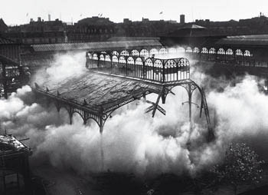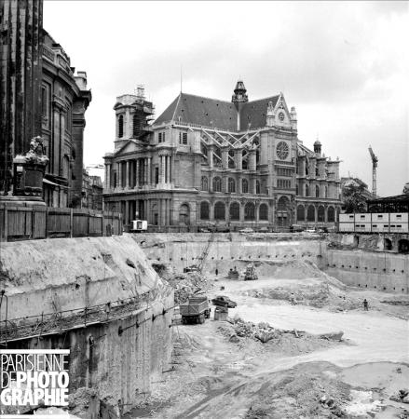
Destruction of the Baltard Halles under military protection, 1971 Trou des Halles (Halles Hole)

In 1963 the centuries-old food Market of the Halles is moved from the center of Paris to the suburbs in Rungis. The authorities decide to rebuild the empty space as a high-density center with underground shops, parking, and a central station for the metro and the RER, the deeper, faster metro serving new cities at the outskirt of Paris. In 1966 preservationist and historical societies oppose this scheme and the destruction of the 19C iron structures of the Baltard Halles. It leads to a long controversy, solved when the structures are torn down with no warning in August 1971. Although most Parisians are vacationing and Paris is at its emptiest, the demolition is nonetheless done under the protection of military forces. The period of the “Trou des Halles” (“the Halles hole”) follows, with the slow construction of retaining walls and the underground subway station.
Much hesitation follows about what to do on top of the hole, and while everyone is busy with the Halles controversy, President Georges Pompidou builds a contemporary art museum in an empty lot nearby, the Pompidou Center known to Parisians as “Beaubourg.” The Beaubourg concept is simple: a boxy container of six stacked-up floors, with open spaces inside for modifiable and multi-use exhibits. The structure, technical conduits and vertical circulations are confined to the outside of the building, in a gutsy gesture never conceived before. The extreme High-Tech style provokes an outcry in Paris, and a flood of metaphors to describe it as an “architectural King-Kong,” an “ideological bomb,” a “big extra-terrestrial,” a gaudy piece of scrap metal, or like my grandmother and everyone else, an oil refinery. Whichever way you might have described it, it brought to an end the hegemony of Modern architecture in Paris, and opened a chapter in postmodern architecture, with its pluralistic approach and playfulness with colors and forms.

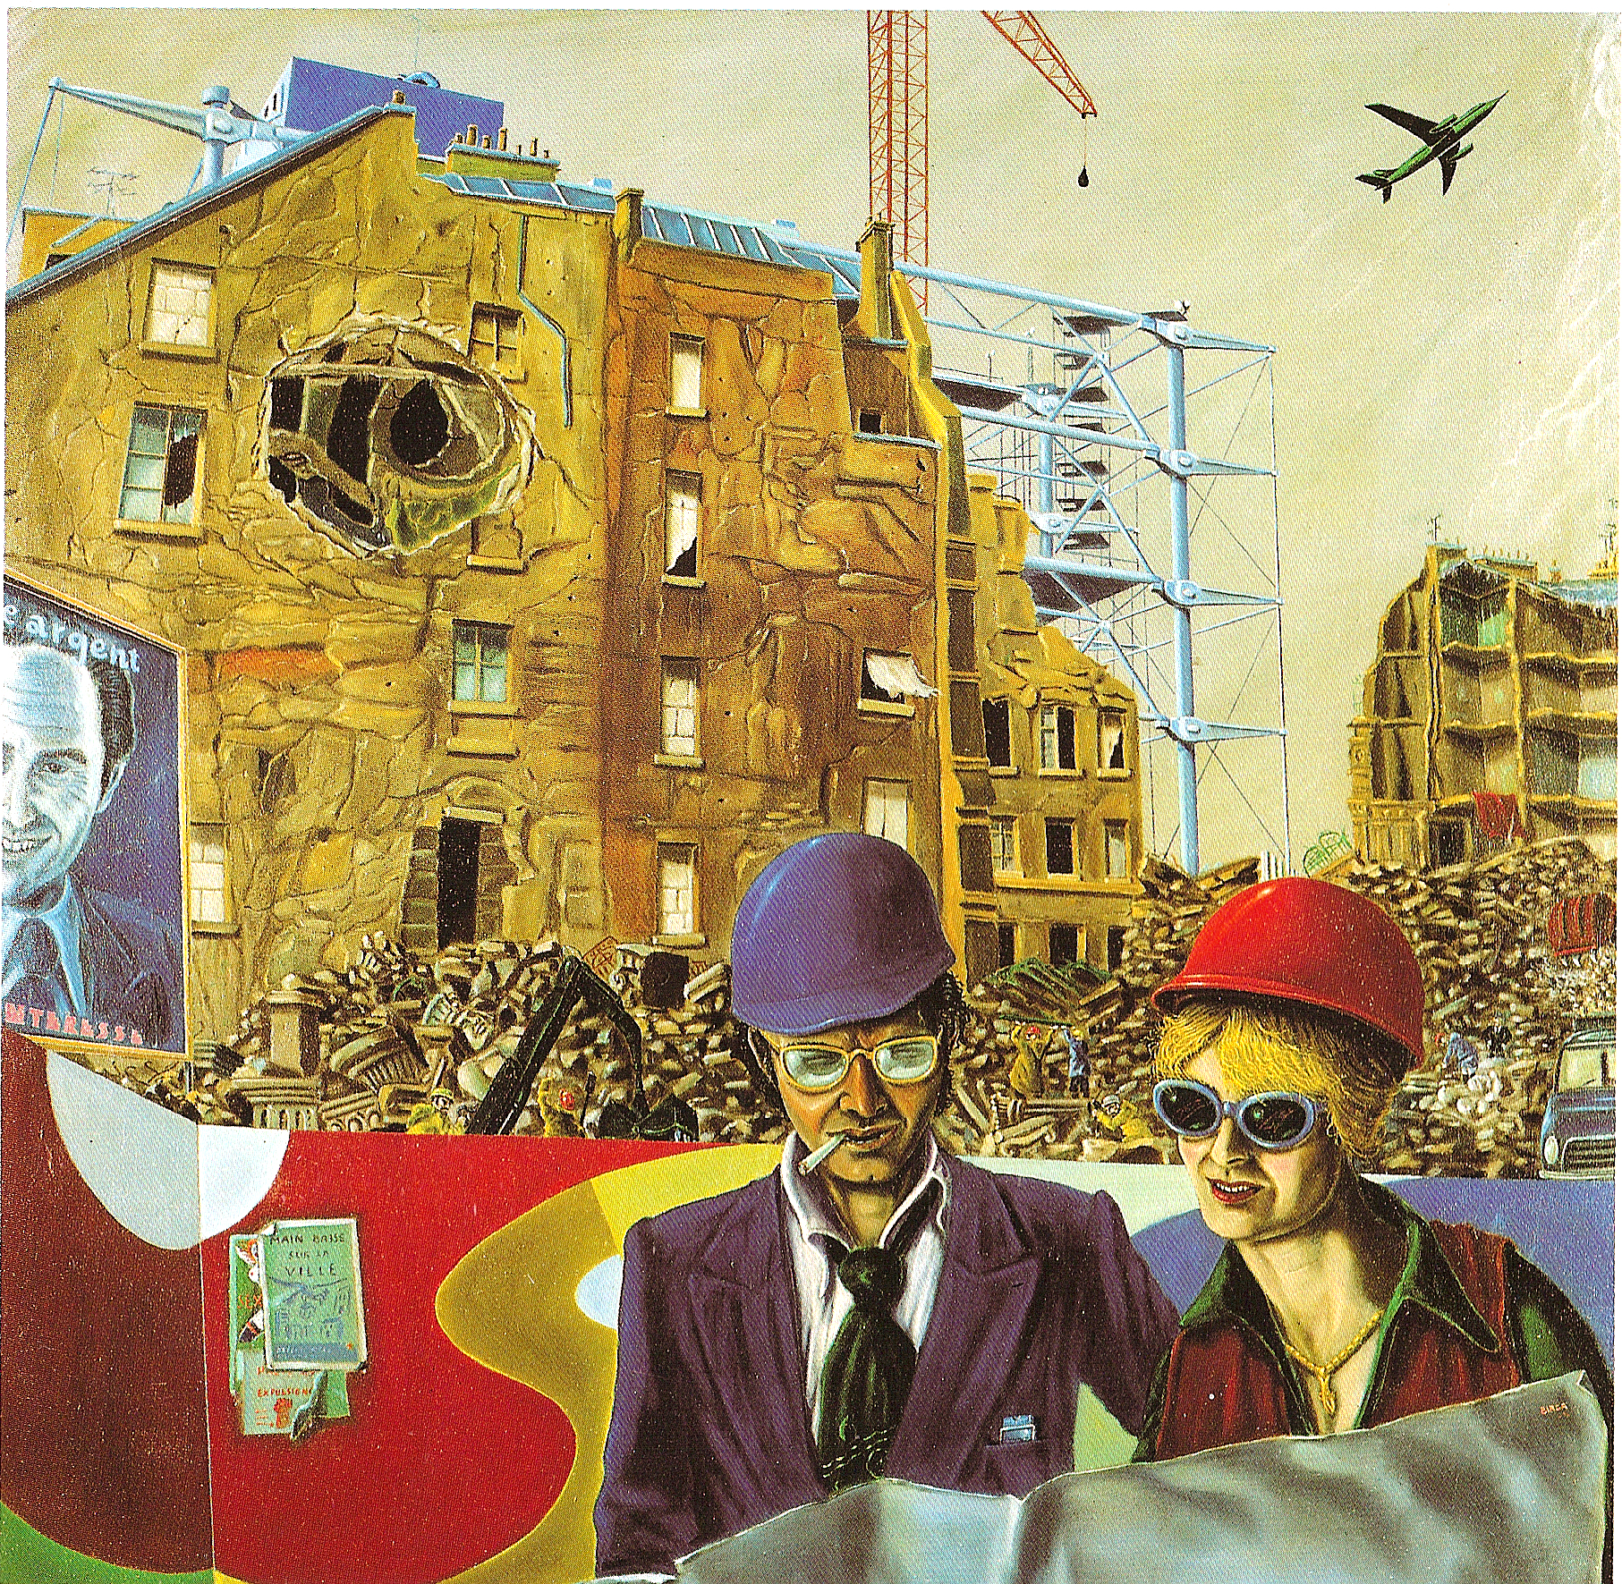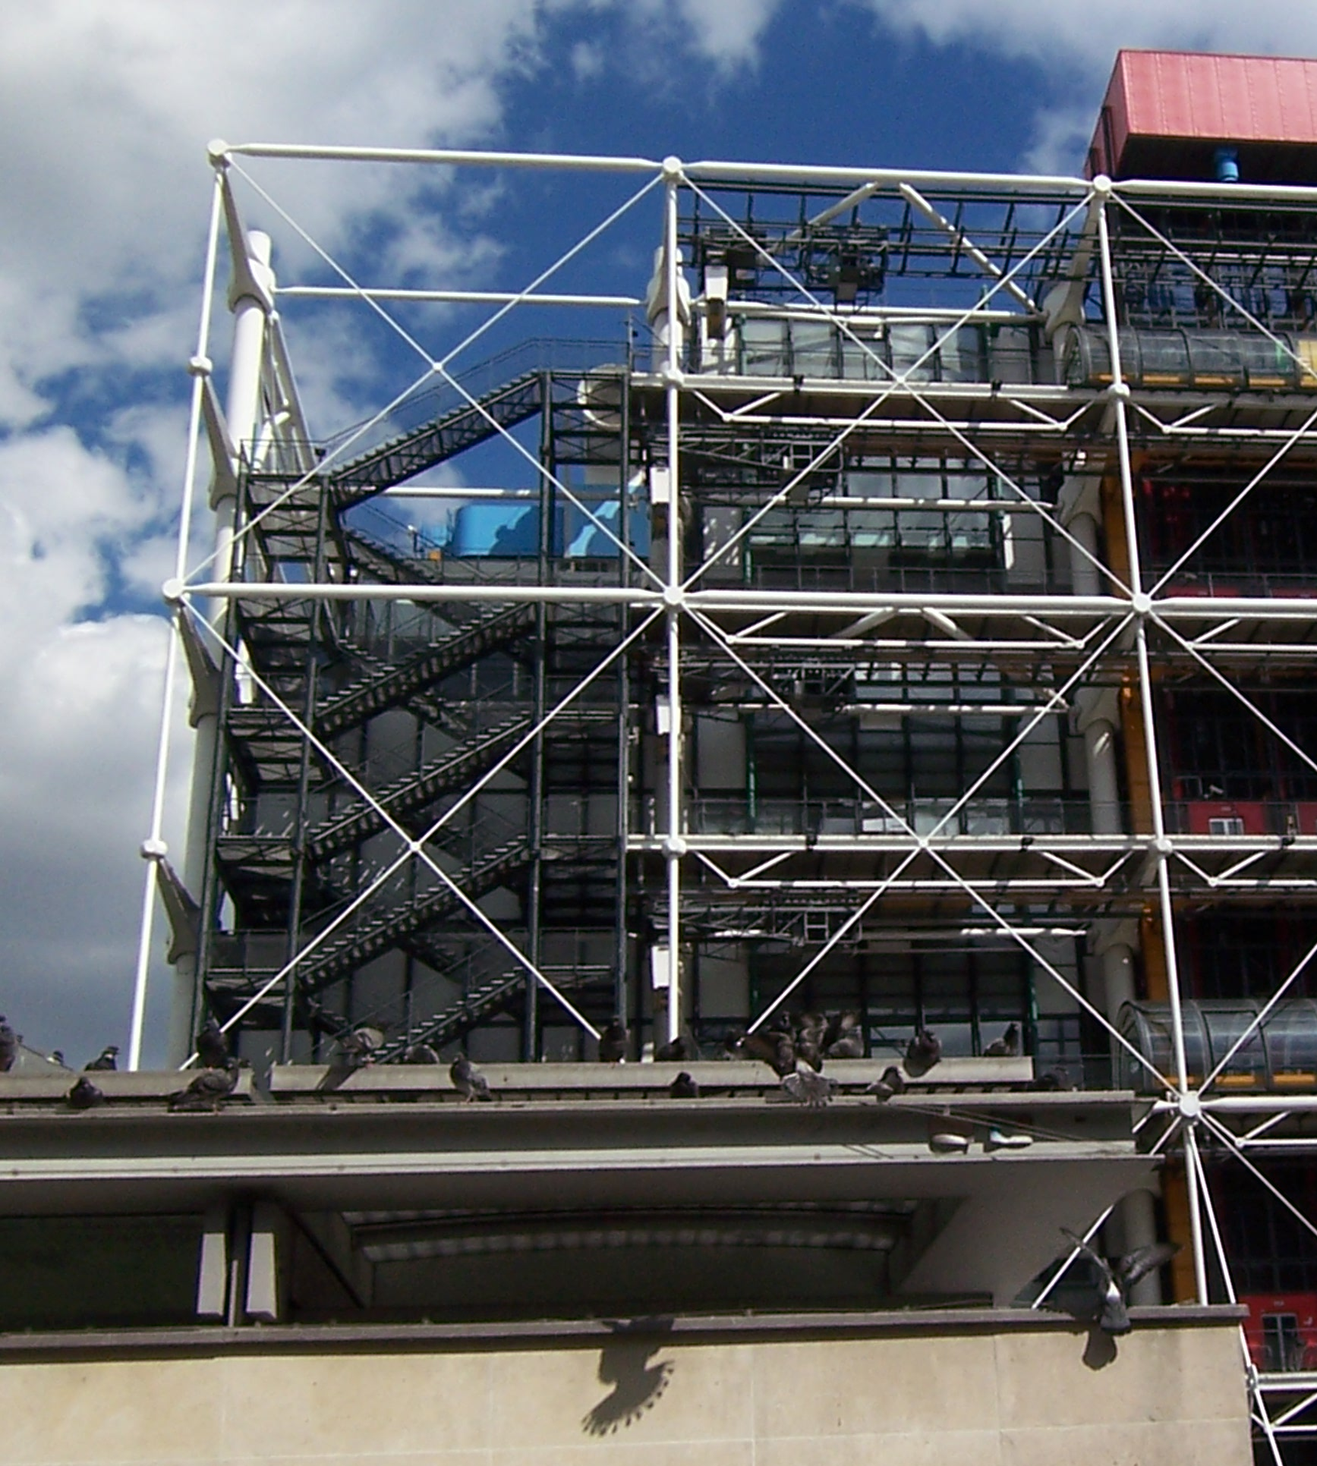
Sergio Birga, Main Basse sur la Ville, 1976 Beaubourg/Pompidou Center (Piano and Rogers, 1977)

In Main basse sur la ville, Birga presents a construction site with a metallic structure recognizable as Beaubourg arising behind a crumbling four-story building. Two people stand in the foreground wearing safety helmets and holding an architectural print that would possibly designate them as the two architects of Beaubourg, Italian Renzo Piano and English Richard Rogers.
The man on the left puts an arm behind the woman, and his olive skin, dark hair, sideway helmet, cigarette at the corner of his mouth, purple suit and unbuttoned collar conspire to represent a flirty Italian caricature: here is Renzo Piano. On the other hand, the white skin and fair hair of the woman to the right are more characteristic of northern countries, and her big teeth caricature her as English. Richard Rogers would be transformed into a woman, and the evidence of a more than professional relationship between them (Piano’s arm and the way they hold the print together) implies a marriage of sort between the two architects. In this sense, the “conception” of an architectural project would be a form of anthropomorphic reproduction. And this is the case of Birga’s building, starting with the facade presented as a living organism.

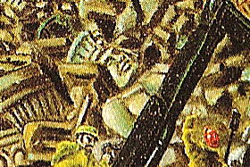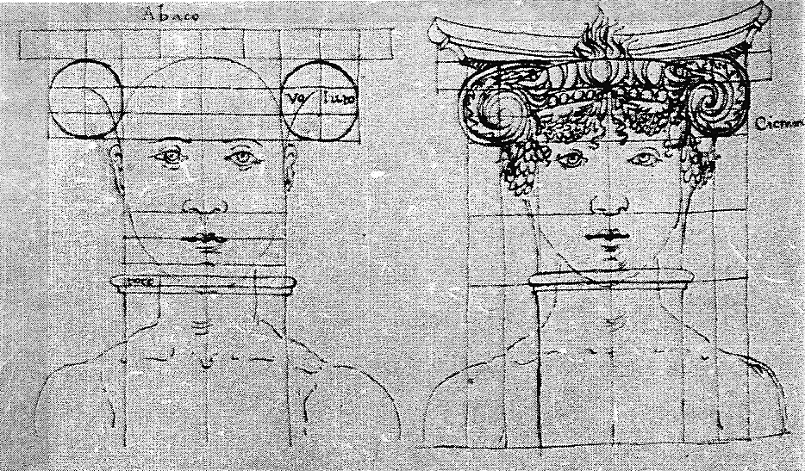
Main basse sur la ville, detail Francesco di Giorgio, Head within a capital. 15C
Frieze fragments and propylae with closed eyes From the Magliabecchiano Codex, folio 33v.

The four-story building that is being demolished is rather plain. Unlike the ubiquitous Haussmannian apartment building, it does not present a floor differentiation with a piano nobile, nor adornments such as balconies or pilasters. Its Parisian specificity amounts to the zinc roof with television antennas and chimneys. However the rubbles at its feet contradict the modesty of the façade, consisting of architectural fragments such as columns, friezes and capitals, as well as a statue whose flattened headdress indicates it served as a propylae. This statue used as a column is a literal transcription of the image of man in a façade, and part of a Renaissance anthropomorphism such as can be seen in 15C Francesco de Giorgio’s drawings, showing how entablatures and capitals took the human body for proportional model (see drawing above). In Main basse, the discarded woman-column closes her eyes as if she was dead, contributing to present the construction of Beaubourg as the death of a classical type of architectural anthropomorphism.
Construction workers with bright-colored helmets are looking through the rumbles, salvaging valuable remnants. Or maybe are they scavengers in a merciless scene of destruction: a curtain flies from a window like a defeated white flag, a child crib sits atop a pile abandoned by fleeing inhabitants, and an airplane takes off in the gray sky (as Parisian sky mostly is) for safer ground. A crane with its weight looms in the sky; it has inflicted a hole in the façade and the walls have wrinkled around it like a living organism shrinking under a blow, rather than a cracking limestone façade. Below the hole, an area red as a wound further presents the trauma inflicted at the heart of Paris by the “ideological bomb” of Beaubourg, which effects are literally exposed here.
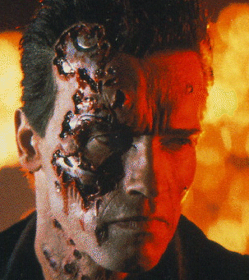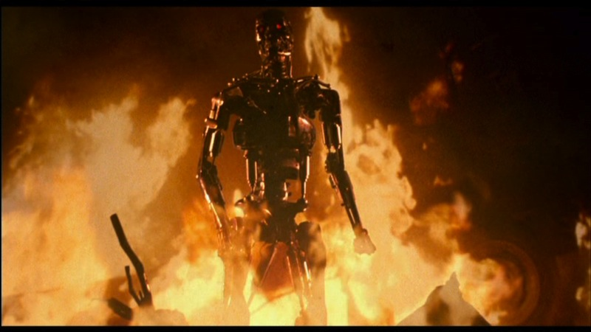
Arnold Schwarzenegger in The Terminator (James Cameron, 1984)

The metal structure of Beaubourg emerges through the dilapidated pieces of wall like the skeleton of the old building revealed under its skin, making of Beaubourg a pre-existing structure that waited for the disappearance of the old building to surge forth in its place. Main basse stages the moment the crumpled skin gives way to Beaubourg, in an apocalyptic scene reminiscent of Cameron’s The Terminator (1984), when Schwarzenegger catching in fire loses the fleshy part of its body, to reemerge in the metallic skeleton beneath. At this point, the film requires two leaps of faith from the spectators. The first one is to accept the fiction of the actor as being a real protagonist in the film—Schwarzenegger as being the Terminator—a convention we are familiar with, and that contributes to our enjoyment. The other leap is to accept the fiction that the Terminator was a machine all along, which we resist—we can’t find Schwarzenegger in the metallic robot and feel cheated by the sudden disappearance of our star actor. The Terminator plays the borderline with man and machine from the other side: unlike other automatons that are machines in the form of a man, the Terminator is a man we discover to be a machine underneath. How brilliantly unsettling. Main basse presents the same phenomena in Beaubourg: it is an android that got rid of its wrinkled skin and exposes its metallic structure beneath.
This aesthetic of exposed structure already existed in the 19C Baltard Halles Napoleon III had wanted to be no more than “umbrellas,” requiring their iron structure to lay bare rather than dressing them up in stone. The unique aspect of Beaubourg is that it also exposes its “insides,” showing its mechanical systems that the minimalist Modern aesthetic worked so hard at hiding. This is what my grandmother implied when teasing me with an amused disgust, “your Beaubourg shows its guts.” And while using the outside aspect of the Vitruvian Man as a model is gratifying, showing its organs is not, even under the disguise of a machine. Beaubourg’s pipes clearly evoke the human body, with precedents like Descartes’s automaton in his 1637 Discourse on the Method, or even just the color-coding we all used to draw the human body systems in primary school. Beaubourg’s anthropomorphism resides in its metal skeleton and guts, the human model repackaged as an inside-out android.
This confusion of categories, inert and alive, inside and outside, makes Beaubourg belong to a postmodern aesthetic defined by Lyotard as a “condition” rather than a style, challenging the modern simplistic classifications and holding realities to be plural and relative. This plurality is further evidenced in Main basse in its portrayal of the architect eye.

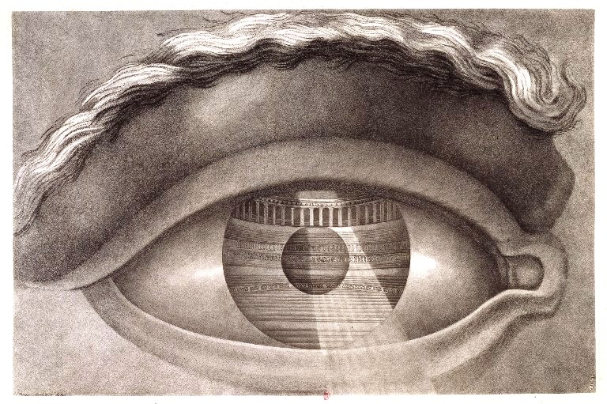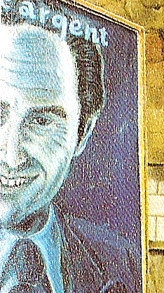
Claude Nicolas Ledoux Main basse sur la ville, detail:
“Eye reflecting the Besancon theater interior,” 1784 Single eye of the smirking man

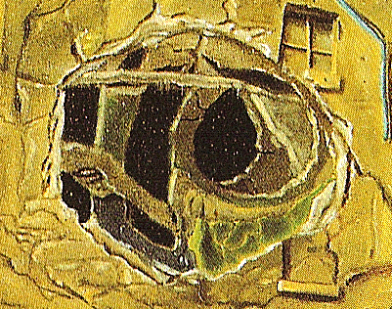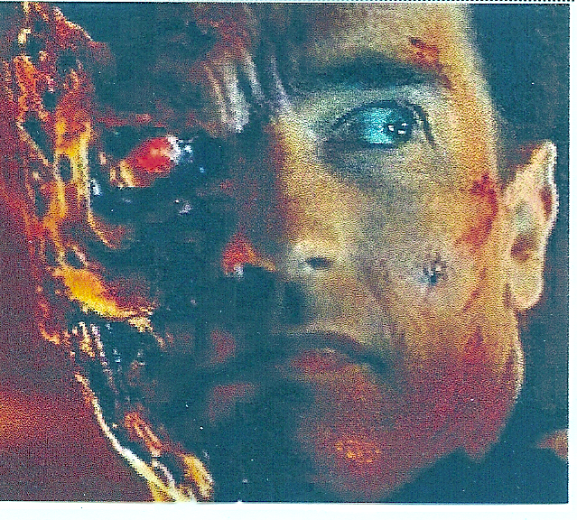
Main basse, detail: hole in the shape of an eye Arnold Schwarzenegger in The Terminator
with an iris like a camera diaphragm with one human eye and one machine/camera eye

In his primordial and legendary experiment on perspective at Florence’s San Giovanni Baptistery, 15C architect Filippo Brunelleschi looks through a panel in which a “small conical hole in the shape of a hat of a woman” has been drilled. The conical hole has the particularity of staging the perspective view as coming from the single eye of the architect placed in one fixed position. In his drawing for the Besançon Theater (see above), 18C architect Ledoux also expresses the perspective eye as single and fixed. The building reflected in the pupil and iris further indicates an all-encompassing eye, while a conical beam of light emanating from the eye acts like orthogonals in a perspective, regulating and ordering the pictorial space. In Main basse, both architects wear glasses. Not only their eyes are not the light source like in Ledoux, but they have to protect themselves from it, with sunglasses for the woman (the perspective point is brilliant, blinding), and prescription glasses for the man (he has a blurred vision, which makes him shut his eyes). Instead of holding the constructed space in its gaze, the architect eye is blinded, blurred and multiplied by four. Furthermore, the architects in Main basse turn their back to the desolate demolition site, physically separating and estranging themselves from it by a fence.
If the architects have four eyes, on the other hand the smirking man on the poster to the left has only one eye. Because of his contiguity to the four-story tall building, we see by metonymical effect an eye in the hole of the façade as well, as if the missing eye of the smirking man had slid on to the building. Wall residues delineate the pupil of this enormous eye like the adjustable diaphragm of a camera, and here again, like android Terminator when he has one human eye and one mechanical eye that works like a camera. The importance given to this hole on the facade also makes it a metonymy for the “Halles hole” brought on by the demolition of Baltard’s Halles. The enormous eye portrays the gaping hole Paris kept at its center for a few years before filling it with mitigated projects trying to reconcile divergent political agendas. Thirty years later, the hole has reappeared. The architecturally compromised solution failed, and the center of Paris is once more a construction site with architect Patrick Berger’s “La Canopée” project, seeking to fill the hole and overcome the threat of a dysfunctional center.
Although the lack of unity and grandeur in the previous Halles architecture was assuredly part of the problem, the threat also has a social component. After World War II, France looked to its former colonies to help rebuild its economy, and housing projects were built in the banlieue to house the increase of immigrants, which the RER serves along with the new cities. Mathieu Kassovitz’s film La Haine (1996) shows how those projects come to haunt and threaten the city, when their deprived and marginalized youth penetrates Paris. This is often done with the RER taking them straight to the central Châtelet station built under the Halles, and although in La Haine the three protagonists have to take a train, they nevertheless end up in the Halles shopping center, where hatred cannot be contained nor avoid a self-perpetuating destruction. The Halles with the underground Châtelet station emerges as a self-engulfing hole deconstructed from its alienated banlieue, a social breach “La Canopée” may not amend. In Main basse, the enormous Halles eye likewise belongs to the deconstructive discourse of the postmodern aesthetic.
Unlike the all-encompassing Ledoux eye, the Halles eye indicates the impossibility of a complete victory over a representation system, what Lyotard calls “l’imprésentable” (the “unpresentable”). The two architects do not hold the perspective view of constructed space, and even more, they turn their back to the enormous eye that bends and looms over them, ready to engulf any plan they will produce. Main basse finally offer its own version of an anthropomorphic model.

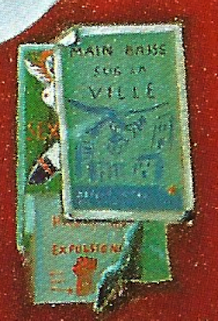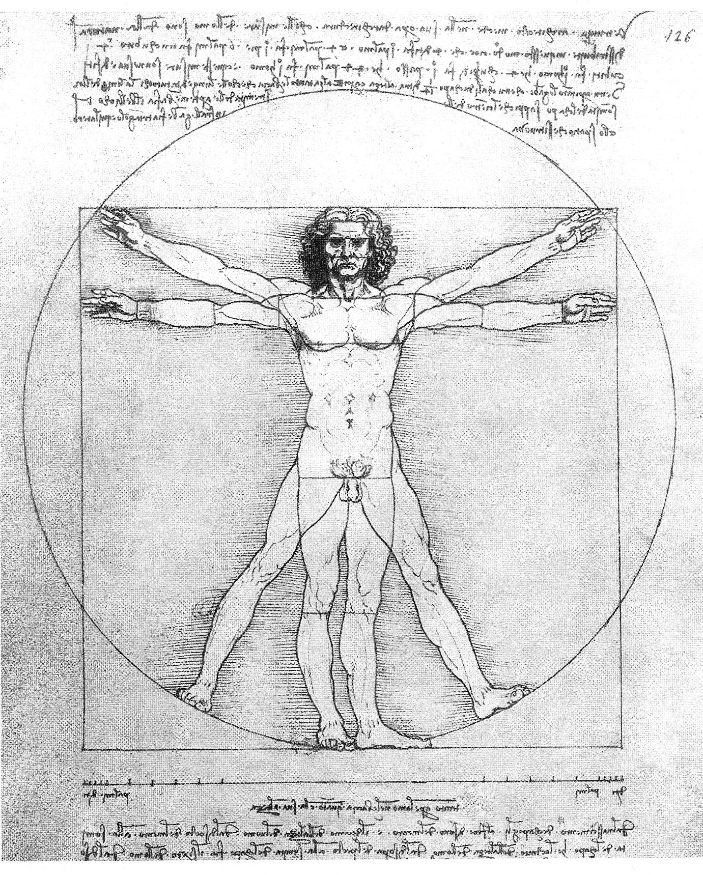
Detail of Main basse sur la ville The Vitruvian Man (Da Vinci, 1487)
The “Halles Woman”

Three posters are glued on the construction fence of Main basse, covering each other like political tracts trying to hide the opponents’ advertisement. However, the masking of previous posters is poorly done and creates a palimpsest of the Halles history.
The poster on top presents a pray bird hovering over buildings with the words “Main basse sur la ville,” which is the name of the painting. “Faire main basse” means to loot or pillage, and indicates the violence perpetrated on the city to be of an economic nature, which is supported by the one-eyed smirking man to the left offering some “argent” in some evil money transaction. The demolition of the Halles is a financial operation in which the soul of Paris itself, either popular housing or historical Baltard Halles, is bought to be destroyed. The pray bird on the poster has already grabbed a building in its sharp claws, and two other buildings stand back in fear, personified with a central door as a gaping mouth and two windows as frightened eyes. Those are the victimized buildings being demolished against their inhabitants’ will.
The “main basse sur la ville” poster covers a notice with words in red saying “EXPULSION,” referring to the eviction of the local residents who could not afford the higher rent of the new housing. A hand closed into a fist under “EXPULSION” indicates that force will be used if necessary, as the army was during the demolition of Baltard’s structures. This banishment to the banlieue has the effect of emptying the center from its righteous inhabitants, although as we saw in La Haine, the deprived inhabitants of the banlieue may come back with the RER, threatening any attempt to rebuild the hole.
Those two posters cover a third partly showing a woman with arms and legs spread apart, exposing her nudity in what we imagine to be a most indecent position. This is funny because she holds the same posture than the Da Vinci’s Vitruvian Man, which is reason enough to give her a name: the Halles Woman. Looking closer, she has a full mane of hair like the Vitruvian Man, although his may not have been red. Like the Vitruvian Man, she has a naked breast. But while his breasts display the powerful muscle of a man, hers is round and bouncing to the side, and has a bright red dot for a nipple that underlines its erotic nature. Her mouth is likewise bright red, and although mostly hidden we can tell it is widely open, forming a gaping, erotic hole metonymic of her sex we do not see. Unlike her, the Vitruvian Man has a tight mouth as well as a fierce stare, where the Halles Woman has only a vague indication of blue where her eye should be, reflecting the sky rather than holding the world in her gaze.
Unlike the Vitruvian man she is not fully naked, but her black hose are hiding the opposite of what is normally hidden. Like the red nipple, the contrasting black color highlights the whiteness of the skin and displays her nudity as sexual, rather than natural like in the case of the Vitruvian Man. The black hose, red hair and posture bring an excess of sexuality that are indicative of a prostitute, which is confirmed with the word “SEX” written in red at the level of what we guess to be her navel. The Vitruvian man’s navel indicates the central place of man in the universe, and in the Halles Woman, the navel indicates likewise the central position of the Halles in Paris. However, instead of indicating the stable center of a circle and a square in which the Vitruvian man is neatly contained, the Halles Woman displays a wild scattering of her members, showing the demolition of the Halles as an explosion at the heart of the city. We cannot see the navel or the sex of the woman, underlining the “unpresentable” nature of the hole of a prostitute, hidden by the other posters that point to its deconstructive nature.
Rather than a representational and proportional model of architecture like the Vitruvian Man, the Halles woman is a metonymical representation of the district, where the content is substituted for the container, and here the prostitute for its quarter. The Halles quarter has traditionally been a district of prostitution, and the remaining Saint-Denis Street with its multiple sex shops has kept the tradition alive. We saw how Lyotard holds realities to be plural and relative. Likewise, the three posters show the cohabiting pluralities of Les Halles. The attempt to create a new image of the area by expulsing the inhabitants and starting over as in a Cartesian tabula rasa has failed. No wonder the two architects of Main basse turn their back on the Halles project and the chaos of its “hole” resurging after thirty years. Meanwhile, Beaubourg has been a success, and it may be due to its own rebellious, brutalist style. The rest of the area still resists an orderly conversion, and the hole has yet to be filled.

See for instance Michel Foucault, “What is an author?” Textual Strategies, Josué Harari ed. (Ithaca: Cornell UP, 1979) 141-60, and Roland Barthes, “The Death of the Author” in Image—Music—Text. Trans. Stephen Heath (New York: Hill and Wang, 1977), 142-48.
At the time, Fermigier warns about the possibility of having a hole if the Baltard’s pavilions are destroyed: “Si l’on détruit les pavillons, que se passera-t-il? Il y aura sur le carreau des Halles un grand trou, puisque les Travaux du R.E.R. doivent s’effectuer en fouille ouverte, et des palissades,” La Bataille de Paris, des Halles à la Pyramide, chroniques d’urbanisme (Paris: Gallimard, 1991), 206.
Here is the French text: “Beaubourg est un coup de force, un viol, une sorte de King-Kong architectural, un aérolithe déposé au cœur du vieux Paris (qu’il a d’ailleurs contribué à sauver). Pourtant il ne pèse guère sur le quartier, il le met même en valeur comme une grosse bête bienveillante, attentive à ses petits, et l’on ne peut qu’être frappé par l’intelligence avec laquelle ont été dégagés ses abords, organisé l’espace qui, du côté de l’église Saint-Merri et du boulevard de Sébastopol s’articule en une série de petites places du plus heureux effet.” André Fermigier, “Autour de Beaubourg. Comment fermer le plateau ?” Le Monde, January 18, 1977.
Georges Pérec, in L’Infra-ordinaire. Paris: Seuil, 1989.
See Louis Chevalier, “Sur le monument lui-même, sur cette ferraille et qui plus est, badigeonnée de rouge, de bleu, de vert dans la splendeur grise de l’horizon parisien, l’opinion des gens est si évidente que point n’est besoin d’y insister.” L’Assassinat de Paris (Paris: Ivrea, 1997), 295.
This is consistent with Robert Venturi’s views in Complexity and Contradiction in Architecture (1966) as he criticizes the Modern movement and its quest of ultimate truth, perfected harmony between form and function, and unadorned, abstracted, purist forms. In contrast, Postmodern Architecture emphasizes plurality over unity, quotes from historical and vernacular styles, relishes into humorous references and playfulness with forms and colors, and reclaims a symbolic value of architecture.
See Marco Frascari on architecture as a reproduction. He writes about Renaissance architect Filatere, “In the beginning of the second book of his treatise, in a discussion of architecture as an anthropomorphic projection, Filarete suggests that buildings are alive like human beings, and that the architect is the mother, whereas the client is the father.” Monsters of Architecture: Anthropomorphism in Architectural Theory (Rowman and Littlefield Publishers, 1991) 13-14. Anne Bergen also brings forth the feminine role in architecture in “Architecture Gender Philosophy” In Strategies in Architectural Thinking, John Whiteman, Jeffrey Kipnis and Richard Burdett eds. (Cambridge, MIT Press. 1992), 9-46.
The “piano nobile,” is the second floor apartment with a higher ceiling, balconies, and more ornate windows.
In George Hersey, The Lost Meaning of Classical Architecture (Cambridge: The MIT Press, 1988) 85-87. See also Marco Frascari, Monsters of Architecture: Anthropomorphism in Architectural Theory (Lanham: Rowman & Littlefield, 1990), 1-2.
Baron Haussmann reports the discussion between architect Baltard and Napoleon III in his “Grands Travaux de Paris,” Mémoires, vol. 3 (Paris: Victor-Havard, 1893), 478-84.
Descartes explains, “This will not seem strange at all to those knowing how many different automata, or moving machines, the human industry can fabricate with only a very few pieces, in comparison with the great multitude of bones, muscles, nerves, arteries, veins, and other parts that are found in the body of each animal. Such persons will look upon this body as a machine made by the hands of God, and incomparably better organized and more admirable in its movements than any invented by men.” Translated from Discours de la méthode, chapter 5 (Paris, Garnier-Flammarion, 1966), 78-79.
In Beaubourg, the cooling pipes are blue, water pipes green, electrical conduits yellow, elevators red and underground ventilation white.
See Jean-François Lyotard in The Postmodern Condition. Manchester: Manchester University Press, 1997. Lyotard comes up with the term of “Postmodernism,” which he defines as a tendency to question the “modern” scientific mentality of objective truth and progress. For Lyotard, apparent realities are social constructs dependent on language and social bond, and he criticizes simplistic classifications such as male versus female, straight versus gay, white versus black.
Much has been written on Brunelleschi’s experiment and perspective in general. See Erwin Panofsky, La perspective comme forme symbolique. Paris: les Editions de Minuit, 1975; Hubert Damisch, The Origin of Perspective. Cambridge: The MIT Press, 1995; James Elkins, The Poetics of Perspective. New York: Cornell University Press, 1994.
See Rodolphe El-Khoury’s comments on Ledoux’s eye in his doctorate dissertation: Visible Environments, Architecture and the Senses in Eighteenth-Century France (Princeton University, 1996), 1-41.
Jean Baudrillard also uses the metaphors of the black-room and oil refinery when speaking of Beaubourg: “A vrai dire, le seul contenu de Beaubourg est la masse elle-même, que l’édifice traite comme un convertisseur, comme une chambre noire, ou, en termes d’input-output, exactement comme une raffinerie traite un produit pétrolier ou un flux de matière brute.” L’Effet Beaubourg, implosion et dissuasion (Paris: Galilée, 1977), 27.
A canopy is defined as a roofed structure serving as a sheltered passageway or area, but also as the highest level of branches and foliage in a forest formed by the tree crowns. Berger claims his steel and glass structure will have a vegetal undulation and be as light as a foliage. Time will tell how an equatorial forest metaphor will work in the middle of Paris.
Jean-François Lyotard states: “Le postmoderne serait ce qui dans le moderne allègue l’imprésentable dans la présentation elle-même; ce qui se refuse à la consolation des bonnes formes, au consensus d’un goût qui permettrait d’éprouver en commun la nostalgie de l’impossible; ce qui s’enquiert de présentations nouvelles, non pas pour en jouir, mais pour mieux faire sentir qu’il y a de l’imprésentable.” Le Postmoderne expliqué aux enfants (Paris: Galilée, 1986), 32-33.
Fermigier writes for instance of the inhabitants’ deportation to “beet fields,” “D’autant plus, on ne le dira jamais trop, que la plupart des immeubles détruits sont des immeubles d’habitation, qui deviennent des surfaces commerciales, presque toujours, d’ailleurs, au prix d’une dérogation. Avec, pour conséquence, l’engorgement du centre de Paris et la déportation de ses habitants vers les champs de betteraves.” La Bataille de Paris, des Halles à la Pyramide, chroniques d’urbanisme, 298.
Roland Barthes points out how it is the shedding of clothes and not the nakedness that is erotic, “Woman is desexualized at the very moment when she is stripped naked […] There will therefore be in striptease a whole series of coverings placed upon the body of the woman in proportion as she pretends to strip it bare.” Mythologies (New York: Hill and Wang, 1972), 84. See also Jean Baudrillard’s analysis of the erotic power of the hose line in L’Échange symbolique et la mort (Paris: Gallimard, 1976), 156.
Diana I. Agrest explains how the feminine body is excluded, or rather repressed, from the anthropomorphic representational system of architecture in “Architecture from Without: Body, Logic, and Sex,” in Theorizing a New Agenda for Architecture. An Anthology of Architectural Theory 1965-1995 (New York: Princeton Architectural Press, 1996), 542.

